CLIENT APPROVAL FORMAT (REVENUE GENERATION PROJECTS)

STUDENT GROUP DETAILS
Names | Shubh Porwal , Pranav Singh , Avinash Raj
Roll Numbers | 58 , 28 , 26
Registration Numbers | 12416962 , 12417050 , 12416147
Emails | Shubhporwal83@gmail.com , pranavsinghkia@gmail.com , avinashshrivastava008@gmail.com
CLIENT DETAILS
Name | Anil Jeweller’s
Email (Official) | Anilporwalbharthana@gmail.com
Contact Number (Official) | 9997364680
Organization/Company Address | Baharpur, Bharthana, Etawah , Uttar Pradesh
REQUIRED DOCUMENT DETAILS (Yes/No)
GST No. / PAN number | 09CWFPK8527F1Z9  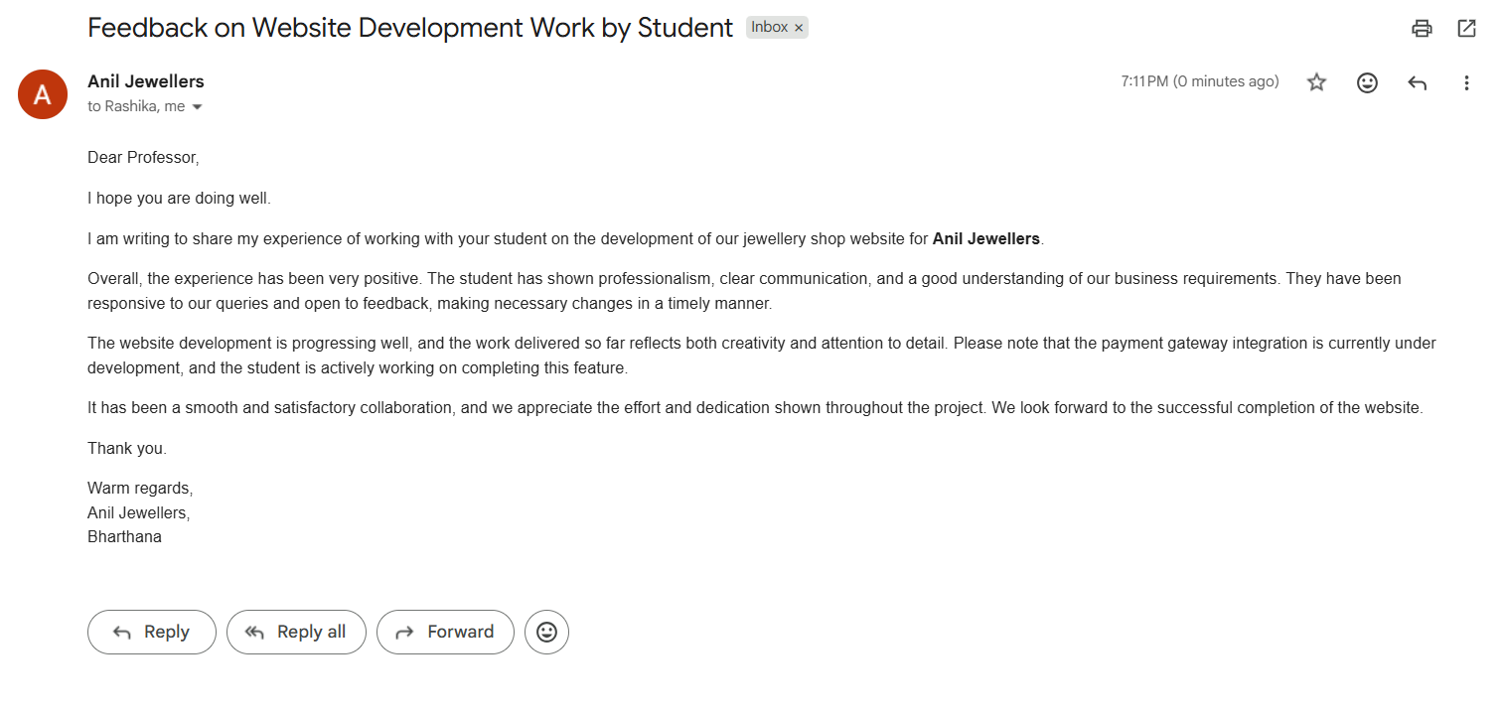
Email Acknowledgement

Client Organization location proof (Google Maps) | https://maps.app.goo.gl/yXJQDhEyCA8CfKNt8
Transaction ID proof | 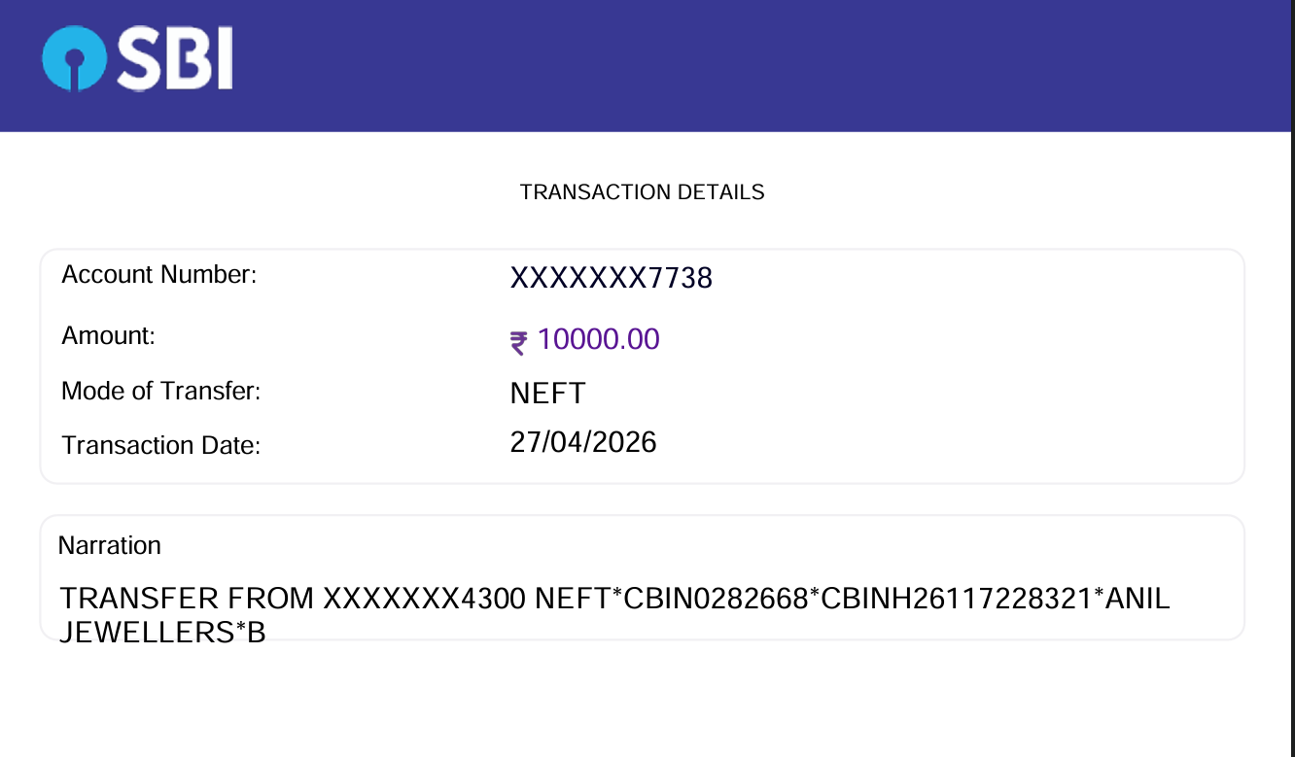

PROJECT SUMMARY
Title and Description | This project presents a modern e-commerce website for Anil Jewellers. The goal is to help a traditional jewellery business expand online and increase revenue.  The website features a user-friendly interface with product categories, detailed item pages, login/signup functionality, and a smooth add-to-cart process. It is fully responsive, ensuring seamless access across devices.  This project demonstrates practical full stack skills, UI/UX design, and the use of technology to support business growth.
Revenue generated (Rs.) | Rs. 10000
Deployed Link | https://www.aniljewellers.shop/
GitHub link | https://github.com/shubhporwal07/Anil-Jewelles

ACCEPTANCE OF PROPOSAL
Authorized Client Signature/ E-Signature | ATE OF ACCEPTANCE  